Chaincase Complete (De Luxe) 24 8717

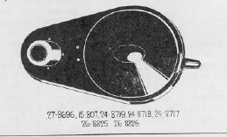

Carburettor Control, Complete with cables & covers (De Luxe) 24 -9494 & without cables & covers 15-980

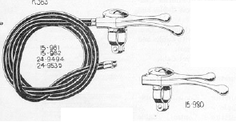

Front Brake Rim (26”x 2¼“ BE) S201


