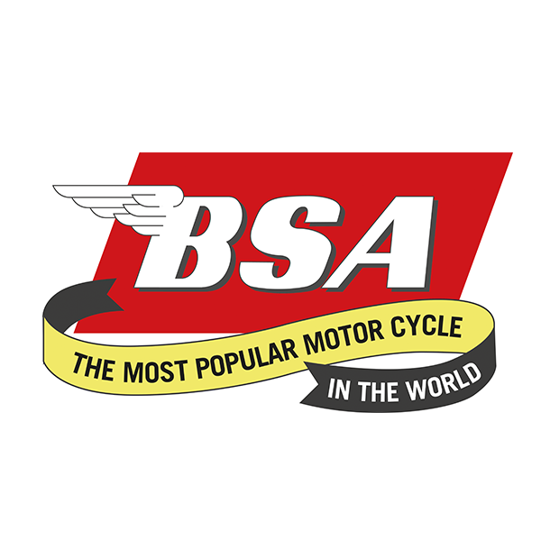
Don’t forget to put the date in your diaries for............
West Yorkshire Branch Camping Weekend
At Squires Café, Newthorpe Lane, Sherburn in Elmet, LS25 5LX
28th to 30th June 2024
IMPORTANT!!! PLEASE CONTACT THE CAFÉ DIRECT TO BOOK AT
https://www.squires-cafe.co.uk/camping/booking-online/
AND TELL THEM YOU’RE FROM THE BSAOC!!
Fees: Tent with a bike is £10 p/n. Tent with a Car £15 p/n. No Hookups available for Tents.. Motorhomes or Caravans £20 p/n with Hookup extra by tokens purchased from the Café.
There is a 24-hour toilet block with showers (Token operated) and remember there will be lots of bikes to see in the car park plus there is also Speedstyle, the onsite Bike clothes and accessory Shop.
Friday - We will welcome you on arrival. Evening meals from the Café and Beer available from the onsite licenced Bar...
Saturday – Breakfast from the Café, then a run out through the rolling Yorkshire countryside to a place of interest...
Saturday Evening – Catering as Friday along with breakfast available on Sunday morning if you feel up to it!!.
We look forward to welcoming friends old and new!!!!

