Motorcycle Charging Systems

In this article I’m going to look at charging systems as used on British bike with Lucas alternators.
The alternator comprises two parts, the rotor which is magnetic and is attached to the end of the crank, and the stator which is fixed and carries a set of electrical windings. Wipac alternators are very similar and use the same circuitry but their components are not interchangeable due to differences in size. A Wipac rotor coupled to a Lucas stator will give a very low output because of the excessive clearance between the rotor and stator.
The stator windings consist of six coils arranged in three sets of series connections which are connected in parallel for output. One side goes to a switch with three lighting positions that bring in one, two or three pairs of coils according to load. The AC output is fed through a rectifier converting it to direct current (DC) suitable for charging the battery. The diagrams below show the three stages of output controlled by the switch used in 6V systems. The wires are usually Green/yellow, Green/black and Green/white but some stators are Mid-green, Dark green and Light Green.

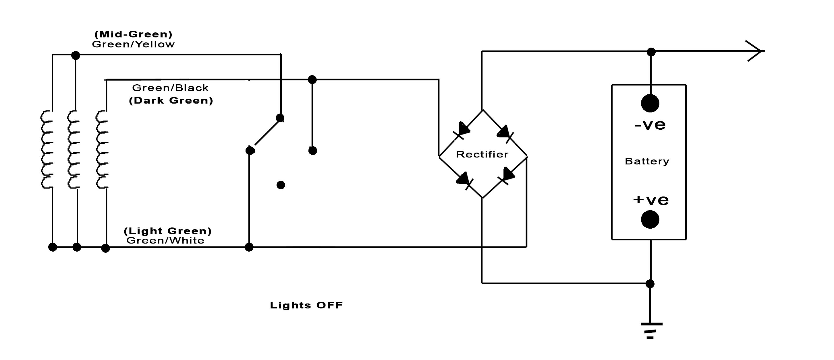
With the lights off the output of the coils connected to green/yellow wire is shorted to ground, reducing the output from the green/black by magnetic interaction.

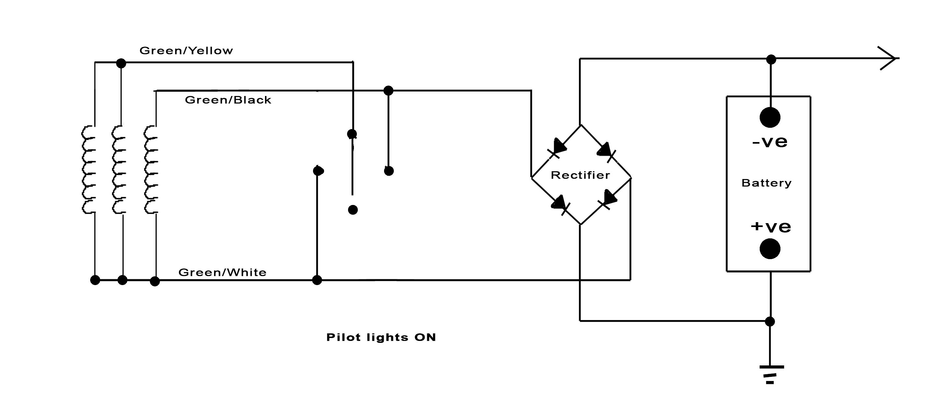
When the pilot lights are on only the output from the coil on the green/black wire is used.

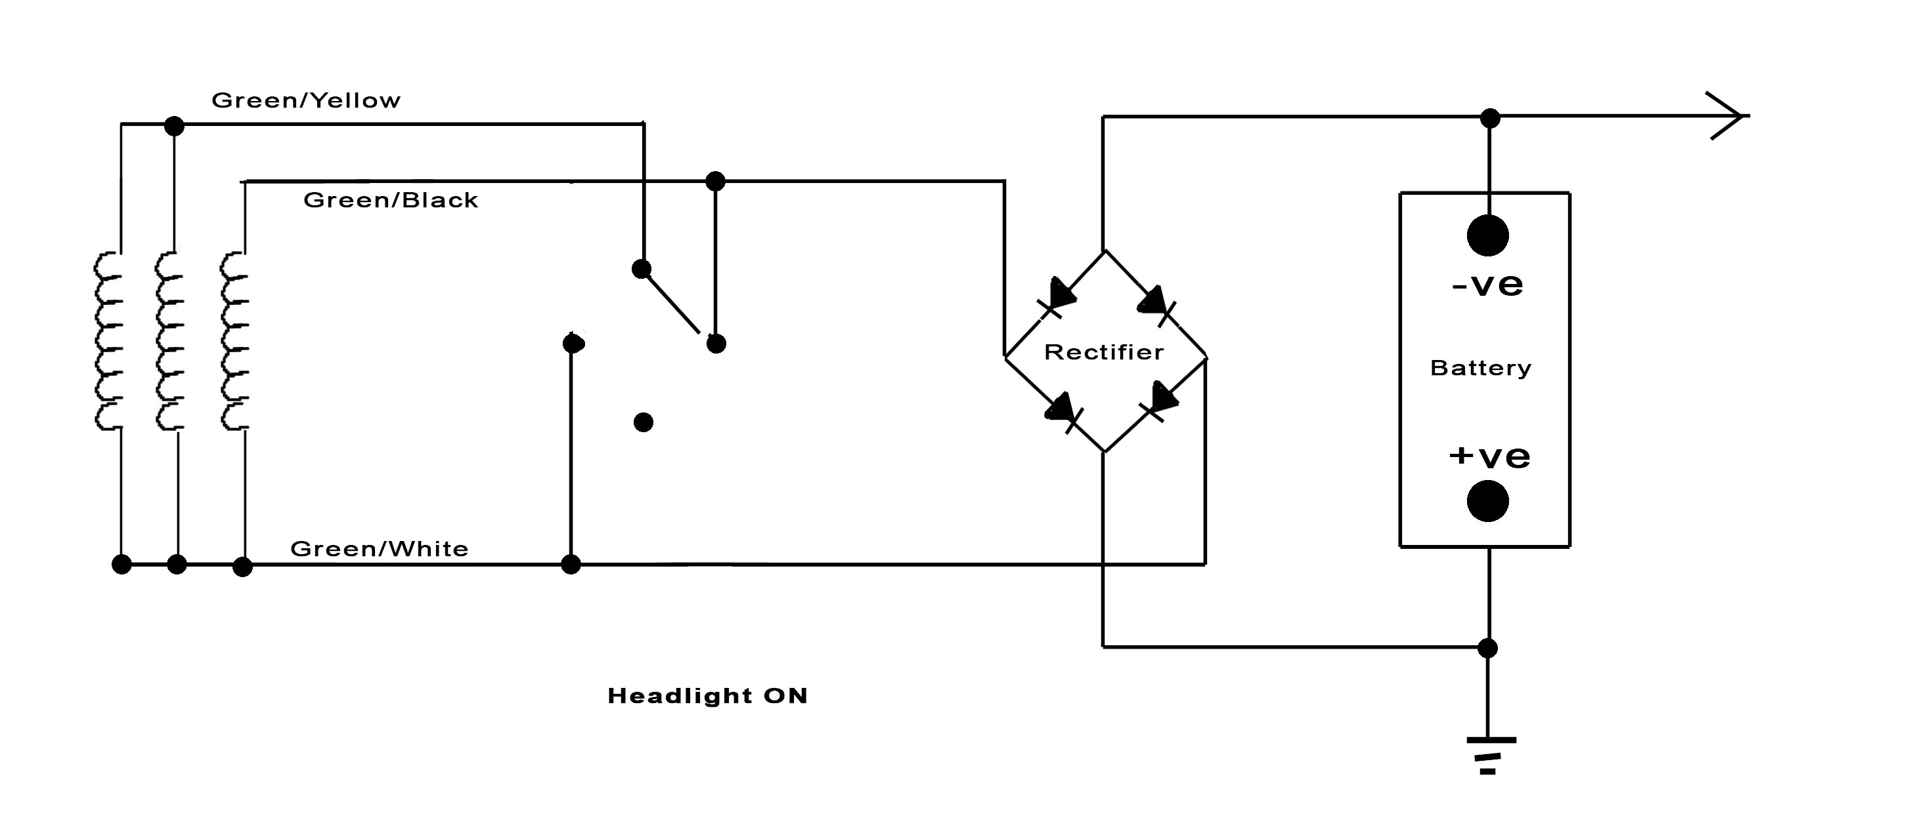
With the headlights on, all outputs are connected giving maximum output

If we look now look at the 12V systems the method of controlling the alternator output is similar but the overall voltage is regulated by the use of a Zener diode.
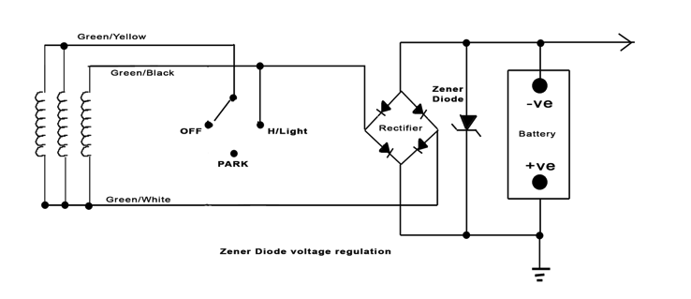
Below 14V the Zener does not conduct electricity but at this point it begins to conduct so that by 15V the bulk of the alternator output is shorted out to pull the voltage down. Of the headlamps are switched on the voltage will drop so the Zener no longer conducts until the voltage again reaches in excess of 14V. In this way the voltage is maintained at approximately 14.4V.
All this excess energy is converted to heat so the diode is mounted a finned heat-sink or a substantial part of the body work to allow the heat to be dissipated.

Later alternators, intended for 12V systems only have 2 output wires where all the three coil pairs are connected in parallel.

Whether 6V or 12V, all of these charging circuits can be replaced with a modern solid state rectifier/regulator which combines the functions of the rectifier and Zener diode as shown below.
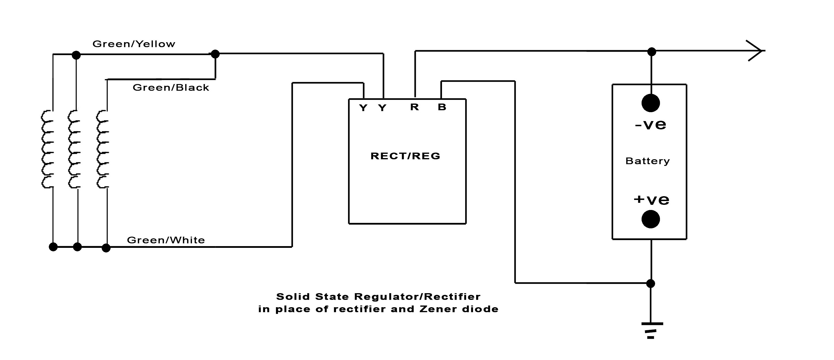

The entire output of the alternator is connected to the input of the rect/reg unit which shunts the excess voltage and disposes of it as heat.

Converting for 6V to 12V

If you never go out at night or for originality, you may prefer to keep your bike at 6V, but 12V has the huge advantage of readily available replacement bulbs and vastly brighter lights. Also, the currents required are less: A 36W 6V headlight bulb will draw 6 amps, whereas a 60W 12V bulb will only draw 5A and since the currents are smaller there is less volts dropped between the battery and the load so it is also more efficient.

If your bike has a Lucas 6V 3-wire alternator system, with a simple wiring change it will be able to power a 12V system.
Disconnect the Green/yellow alternator wire from the loom and join it to the Green/black alternator wire. That's it. The job's done.
Any of the resin encapsulated alternator stators will easily provide sufficient output to run a 60/55W headlight but earlier alternators from before the mid-sixties will struggle and you might have to settle for a 45W headlight.
The existing 6V rectifier will be OK, but you need some form of Voltage control. Fit either a Zener diode or remove the rectifier and fit a modern regulator/rectifier unit . These are more reliable, more efficient and easy to fit.
Fit 12V coils unless you're using electronic ign. then 2 x 6V coils or a 12V twin output coil (For a twin)
A 6V horn will be OK, but will sound louder & higher pitched. Cheap foreign horns may not last long
Obviously you will need bulbs. If you've fitted a new alternator a 60/55W headlight bulb will be OK and give you a light as bright as a cars. If you're sticking with the old alternator a 60/55W will probably be OK, but a 45/40W is guaranteed.
For the battery, measure up for the largest battery that will fit.

Derek Blackie
Sept. 2017

