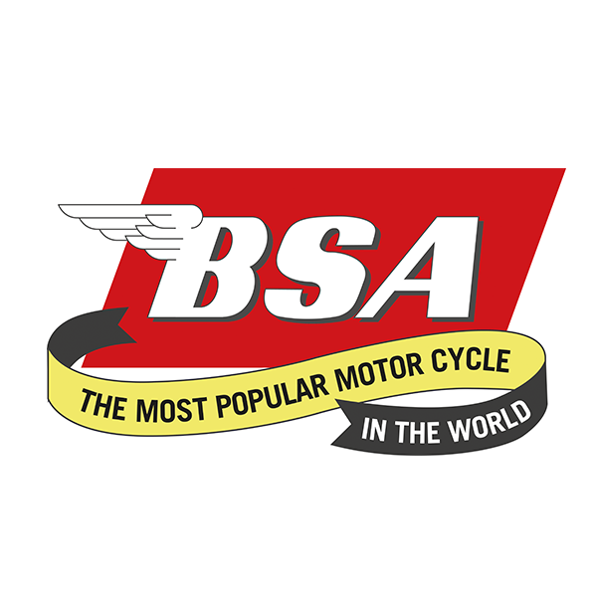
Don’t forget to put the date in your diaries for............
West Yorkshire Branch Camping Weekend
At the 'Linton Lock Inn', Linton on Ouse, York YO30 2AZ.
30th June – 2nd July 2023
Friday - We will welcome you on arrival. Evening meals available from the Pub...
Saturday - A run out through the rolling Yorkshire countryside to a place of interest...
Saturday Evening – Catering as Friday.
Our lovely Anita will rustle up Breakfast butties on Saturday and Sunday for a reasonable cost.
Anyone requiring a Motorhome pitch with Electric Hook up please contact Wendy on 01347 848844 to confirm ASAP due to limited spaces. Cost will be £25 per night.
Camping is £7 PP/PN but please confirm your attendance with Wendy on number above as again, space limited!!!
We look forward to welcoming friends old and new!!!!

