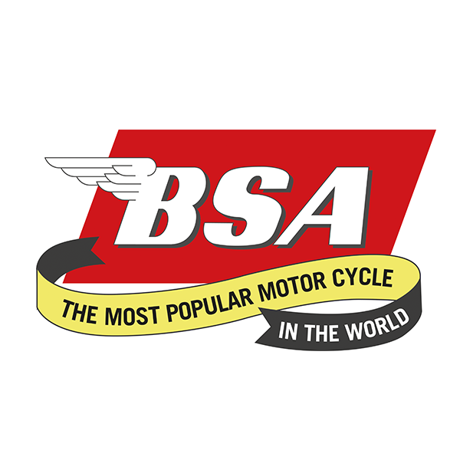
Don’t forget to put the date in your diaries for............
West Yorkshire Branch Camping Weekend
The Sloop Inn, Temple Hirst, near Selby, YO8 8QN
Phone: 01757 270267
17th – 19th June 2022
Friday - We will welcome you on arrival. Evening meals available from the Pub...
Saturday - A run out through the rolling Yorkshire countryside to a place of interest...
Saturday Evening – Catering same as Friday.
Breakfast will be available on Saturday and Sunday.
Anyone requiring Electric Hook up please contact the Pub to confirm ASAP (subject to extra charge per night).
Camping is a nominal fee per night.
We look forward to welcoming friends old and new!!!!

