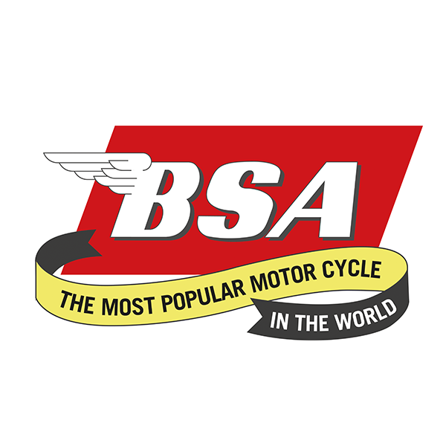
Don’t forget to put the date in your diaries for............
West Yorkshire Branch Camping Weekend
The Breighton Ferry, Breighton, YO8 6DH
2nd – 4th July 2021 *
Friday - We will welcome you on arrival. Evening meals available from the Pub...
Saturday - A run out through the rolling Yorkshire countryside to a place of interest...
Saturday Evening – Catering same as Friday plus Music to dance to with Bar until late.
Breakfast will be available on Saturday and Sunday at reasonable cost with no advance booking required.
Camping is £5 per person per night. Note, this site has very good Toilet, Shower & Laundry facilities...
We look forward to welcoming friends old and new!!!!
*MAY BE SUBJECT TO CHANGE DUE TO COVID RESTRICTIONS

